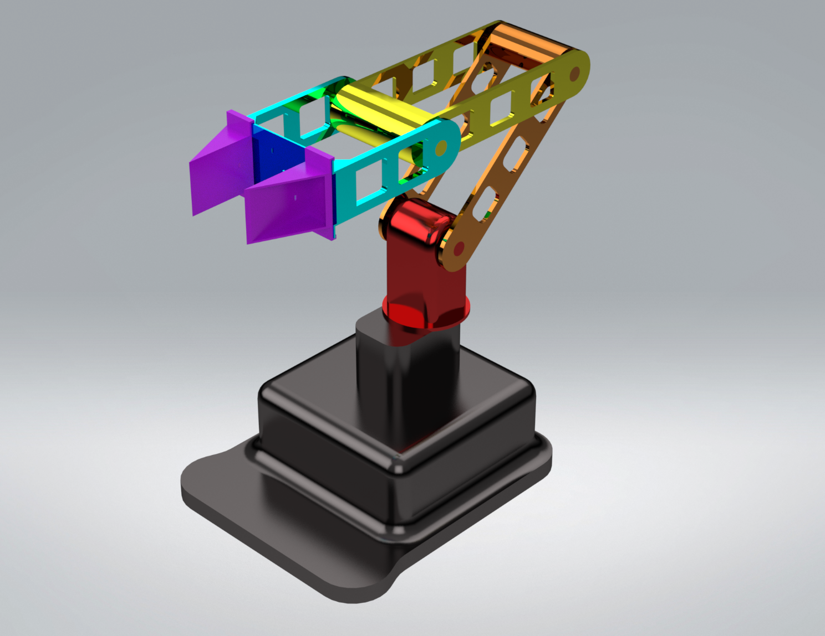

**End Effectors**

**Link 2**

**Link 3**

**Link 4**

**Link 1**

**Base Link**

|  |  |  |  |  |
| --- | --- | --- | --- | --- |
| ***Link*** | ${}_{i}$***(rad)*** | $d_{i}$***(m)*** | $a_{i} / A_{i}$***(m)*** | $a_{i}$***(rad)*** |
| 1 | $${}_{1}$$ | 0.045 | 0 | π / 2 |
| 2 | $${}_{2}$$ | 0.107 | 0 | 0 |
| 3 | $${}_{3}$$ | 0.107 | 0 | 0 |
| 4 | $${}_{4}$$ | 0.109 | 0 | 0 |